Modification History:

|  |  |  |  |  |
| --- | --- | --- | --- | --- |
| **Unique Identifier for this Version** | **Date of the Document Version** | **Author** | **Significant Changes from Previous Version** |  |
|  |
| 1 | 16-Jun-2017 | Mike Schembri |  |  |
|  | 28 June 2017 | Alan Hopkins | Adapted for R Functions |  |
|  | 25-July-2017 | Mike Schembri | Add Introduction, General Description |  |
|  | 8/21/2917 | Mike Schembri | Edits from 7/26 meeting |  |
|  | 08-Nov-2017 | Gustav Bernard | Updates with Andy and Nancy |  |
|  | 31-Jan-2018 | Nancy Brucken and Andy Miskell | Updates for Table part of display |  |

# Outliers or Shifts from Normal to Abnormal White Paper Requirements Specification

## Figure 11.1 Scatter Plot – Quantitative Safety Measures Assessing Low Value

## Introduction

#### Purpose

The purpose of this program is to produce the following scatter plot of minimum baseline vs minimum post-baseline value, as described in the white paper:

*Analyses and Displays Associated with Outliers or Shifts from Normal to Abnormal: Focus on Vital Signs, Electrocardiogram, and Laboratory Analyte Measurements in Phase 2-4 Clinical Trials and Integrated Summary Documents*

Figure 11.1 Scatterplot and Shift Summary for Quantitative Safety Measures Assessing Low Value: Individual Study

#### Scope

The macro will be run in SAS 9.4 TS Level 1M2 or higher.

#### Definitions

## General Description

#### Perspective

This will be one of several macros used to produce the displays described in the white paper.

#### Functions

This will produce one scatter plot of minimum baseline vs minimum post-baseline value, stratified by treatment arm, with a diagonal reference line for zero change, and vertical and horizontal reference lines for high/low ranges.

#### Assumptions and Dependencies

* ADaM BDS data structure is required
* Requires the PhUSE CS macro library:   
   <https://github.com/phuse-org/phuse-scripts/tree/master/whitepapers/utilities>
* User must ensure that SAS can find PhUSE CS macros in the SASAUTOS path.

## Specific Requirements

### SAS Script or R Function Specifications

#### Specific Output Requirements

* Basic script functionality (user options)
* ***data display features***
* Scatter plot, as described in [SAS/STAT 9.4 Graph Template Language: Reference (Scatterplot Statement)](https://support.sas.com/documentation/cdl/en/grstatgraph/69718/HTML/default/viewer.htm#p08qhdljvzthmnn1vkbule00ad6r.htm) or R ggplot function
* X-Axis: Minimum Baseline Value [min(AVAL) where Flag = Y or ABLFL = Y(if this presents the Minimum baseline value) ]
* Flag = Minimum Baseline Value per Subject per Test.
* Both Standard and Conventional Unit needs to be displayed.
* Variable with Conventional unit per test.
* Variable with Conversion Ration per test from SI to Conventional unit.
* Y-Axis: Minimum Post-Baseline Value [min(AVAL) where Flag = Y]
* Flag = Flag for Minimum Post Baseline Value per Subject per Test.
* Both Standard and Conventional Unit needs to be displayed.
* Variable with Conventional unit per test.
* Variable with Conversion Ration per test from SI to Conventional unit.
* Grouped by treatment [TRTP/TRTA/TRTPGy/TRTAGy]
* reference ranges - options to draw reference lines for various scenarios (based on values found in data [(ANRLO and ANRHI) or (AyLO and AyHI)]
* **uniform:** DEFAULT. If all reference range values are uniform for a set of measures, draw those uniform low/high reference range line.
* **narrow:** If the limits vary across the population , the limits that apply to the majority of the subjects are displayed in the scatter plot.
* **all:** Discouraged by white paper authors – draw all reference lines relevant to the set of measures.
* **none**
* **Manually specify numeric value(s):** draw exactly these specific reference lines (e.g., a zero (0) line for change from baseline boxplots.
* Diagonal reference line for no change from baseline to follow-up
* X and Y axis both use the same value range – AVAL

## Figure 11.1 Shift Table Summary of Absolute Lab Values – Minimum Baseline vs. Minimum Post-Baseline

## Introduction

#### Purpose

The purpose of this program is to produce the shift table of minimum baseline vs minimum post-baseline value, as described in the white paper:

*Analyses and Displays Associated with Outliers or Shifts from Normal to Abnormal: Focus on Vital Signs, Electrocardiogram, and Laboratory Analyte Measurements in Phase 2-4 Clinical Trials and Integrated Summary Documents*

Figure 11.1 Scatterplot and Shift Summary for Quantitative Safety Measures Assessing Low Value: Individual Study

#### Scope

The macro will be run in SAS 9.4 TS Level 1M2 or higher.

#### Definitions

## General Description

#### Perspective

This will be one of several macros used to produce the displays described in the white paper.

#### Functions

This will produce two tables – one a frequency table of shifts from each level at baseline to each level at minimum post-baseline. The second table is a frequency table of Normal and High values at baseline to minimum value of Low at post-baseline with a Fishers Exact Test p-value included.

#### Assumptions and Dependencies

* ADaM BDS data structure is required
* Requires the PhUSE CS macro library:   
   <https://github.com/phuse-org/phuse-scripts/tree/master/whitepapers/utilities>
* User must ensure that SAS can find PhUSE CS macros in the SASAUTOS path.

## Specific Requirements

### SAS Script or R Function Specifications

#### Specific Output Requirements

* Basic script functionality (user options)
* All denominators for both tables are based on the number of patients with non-missing SHIFTy values for that parameter.
* ***data display features for first table***
* Treatment and treatment counts in left column
* SHIFTy variable for flagging from minimum baseline to minimum post baseline. Minimum baseline categories shall be displayed per treatment in second column. Minimum post-baseline categories shall be displayed in columns across page.
* Counts and percentage of unique subjects (USUBJID) each cell shall be displayed.
* ***data display features for second table***
* Treatment in left column
* Second column is treatment count
* SHIFTy variable for flagging from minimum baseline to minimum post baseline. Subset out any values that do not have minimum baseline of Normal or High AND do not have minimum post-baseline of Low. Count is third column and Percentage is fourth column. Fishers Exact Test p-value is fifth column

* ***User variability (arguments for R function)***
* location and name of each input data sets
* output location (user-specified path)
* parameterize core variables required for analysis & display:
* "Treatment name" which could be planned or actual [TRTP/TRTA/TRTPGy/TRTAGy]
* "Treatment number" used for display order of Treatment Names [TRTPN/TRTAN/TRTPGyN/TRTAGyN]
* Baseline visit value for AVISITN
* Follow-up visit value for AVISITN
* AVAL (measured outcome)
* ANRLO (lower limit of reference range)
* ANRHI (upper limit of reference range)
* AVISITN (Analysis Visit)
* SHIFTy (Minimum baseline to minimum post-baseline Shift value)
* Comparator treatment (i.e. Reference Treatment value)
* Record set selection (Optional)
* Analysis Flags, e.g.:
* FASFL (full analysis set population flag)
* SAFFL (population flag)
* ANL01FL (analysis flag)
* Time point selection: ATPT – comment from Andy and Nancy – should not need this parameter. Just need to flag correct record (i.e. minimum to minimum) for each subject
* Where statement criteria

#### General Output and Formatting Requirements

See the specification document *CS_GeneralOutputandFormattingRequirements.docx.*

It is recommended that displays use unique plot symbols (or line patterns) for each data series so that they are interpretable by readers with color blindness.

### Usage Requirements

#### Required Input*

##### Laboratory Domain

* Dataset: ADLBC or ADLBH or ADLBHY or ADLB
* Variables: STUDYID, USUBJID, FASFL/SAFFL/ANY OTHER POPULATION FLAG, [(TRTP and TRTPN) or (TRTA and TRTAN)], PARAM, PARAMCD, AVAL, [(ANRLO and ANRHI) or (AyLO and AyHI)], SHIFTy, Flag variables to Identify Minimum Baseline and Post-Baseline observations.
* Three BDS approaches
* If Baseline for the study is the Minimum Baseline Value Then Flag will be ABLFL to identify Baseline Result.
* If Baseline for the study is different than the Minimum baseline value the:
* Create Separate ADLB file with Minimum Baseline Value as Baseline Definition Use ABLFL to identify baseline observation
* Create Separate rows in the ADLB file where BASETYPE = “MIN” for use of the additional Baseline Criteria, use BASETYPE = “MIN” and ABLFL = “Y” to identify baseline observation.
* Record selection
* Population Flag
* Flag = Minimum Baseline Value per Subject per Test.
* Flag = Flag for Minimum Post Baseline Value per Subject per Test.
* Subject will require to have both a Minimum Baseline and Post Baseline value.

##### Vital Signs Domain

* Dataset: ADVS
* Variables: STUDYID, USUBJID, FASFL/SAFFL/ANY OTHER POPULATION FLAG, [(TRTP and TRTPN) or (TRTA and TRTAN)], PARAM, PARAMCD, AVAL, [(ANRLO and ANRHI) or (AyLO and AyHI)], SHIFTy, Flag variables to Identify Minimum Baseline and Post-Baseline observations.
* Three BDS approaches
* If Baseline for the study is the Minimum Baseline Value Then Flag will be ABLFL to identify Baseline Result.
* If Baseline for the study is different than the Minimum baseline value the:
* Create Separate ADVS file with Minimum Baseline Value as Baseline Definition Use ABLFL to identify baseline observation
* Create Separate rows in the ADVS file where BASETYPE = “MIN” for use of the additional Baseline Criteria, use BASETYPE = “MIN” and ABLFL = “Y” to identify baseline observation.
* Record selection
* Population Flag
* Flag = Minimum Baseline Value per Subject per Test.
* Flag = Flag for Minimum Post Baseline Value per Subject per Test.
* Subject will require to have both a Minimum Baseline and Post Baseline value.

##### ECG Domain

* Variables: STUDYID, USUBJID, FASFL/SAFFL/ANY OTHER POPULATION FLAG, [(TRTP and TRTPN) or (TRTA and TRTAN)], PARAM, PARAMCD, AVAL, [(ANRLO and ANRHI) or (AyLO and AyHI)], SHIFTy, Flag variables to Identify Minimum Baseline and Post-Baseline observations.
* Three BDS approaches
* If Baseline for the study is the Minimum Baseline Value Then Flag will be ABLFL to identify Baseline Result.
* If Baseline for the study is different than the Minimum baseline value the:
* Create Separate ADEG file with Minimum Baseline Value as Baseline Definition Use ABLFL to identify baseline observation
* Create Separate rows in the ADEG file where BASETYPE = “MIN” for use of the additional Baseline Criteria, use BASETYPE = “MIN” and ABLFL = “Y” to identify baseline observation.
* Record selection
* Population Flag
* Flag = Minimum Baseline Value per Subject per Test.
* Flag = Flag for Minimum Post Baseline Value per Subject per Test.
* Subject will require to have both a Minimum Baseline and Post Baseline value.

* Digits in red may be substituted for appropriate index (02, 03, etc).

### Test Data

* Data sets from <https://github.com/phuse-org/phuse-scripts/tree/master/data/adam/cdisc>
* Domain data
  + ADVS – Vital signs
  + ADLBC, ADLBH, ADLBHY, ADLB – Laboratory measures
  + ADEG – ECG measures

### Sample Output

**Scatterplot and Shift Summary for Quantitative Safety Measures Assessing Low Value: Individual Study**



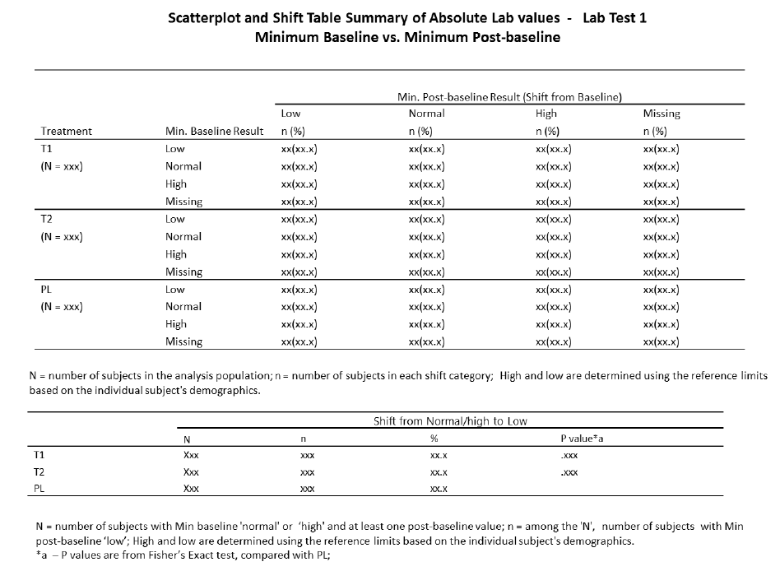

### Reference Documents:

White paper: <http://www.phusewiki.org/wiki/images/4/48/CSS_WhitePaper_CentralTendency_v1.0.pdf>

Programming Guidelines: <http://www.phusewiki.org/wiki/index.php?title=WG5_P02_Programming_Guidelines>

For R:

Wickham, H. (2015) R Packages: Organize, Document, and Share Your Code. Sebastapol, CA: O’Rielly. or online at <http://r-pkgs.had.co.nz/>

Google R Style Guide. <https://google.github.io/styleguide/Rguide.xml>

CS_General_OutputandFormattingRequirements.docx: <https://github.com/phuse-org/phuse-scripts/blob/master/whitepapers/specification/CS_General_OutputandFormattingRequirements.docx>